- Use comments field on the mashup to allow maintain any extra comments plus the actual user recording the test results. This information should then be recorded against the test on the request ID and displayed both in M3 (QMS400/B1) and on the Mashup.
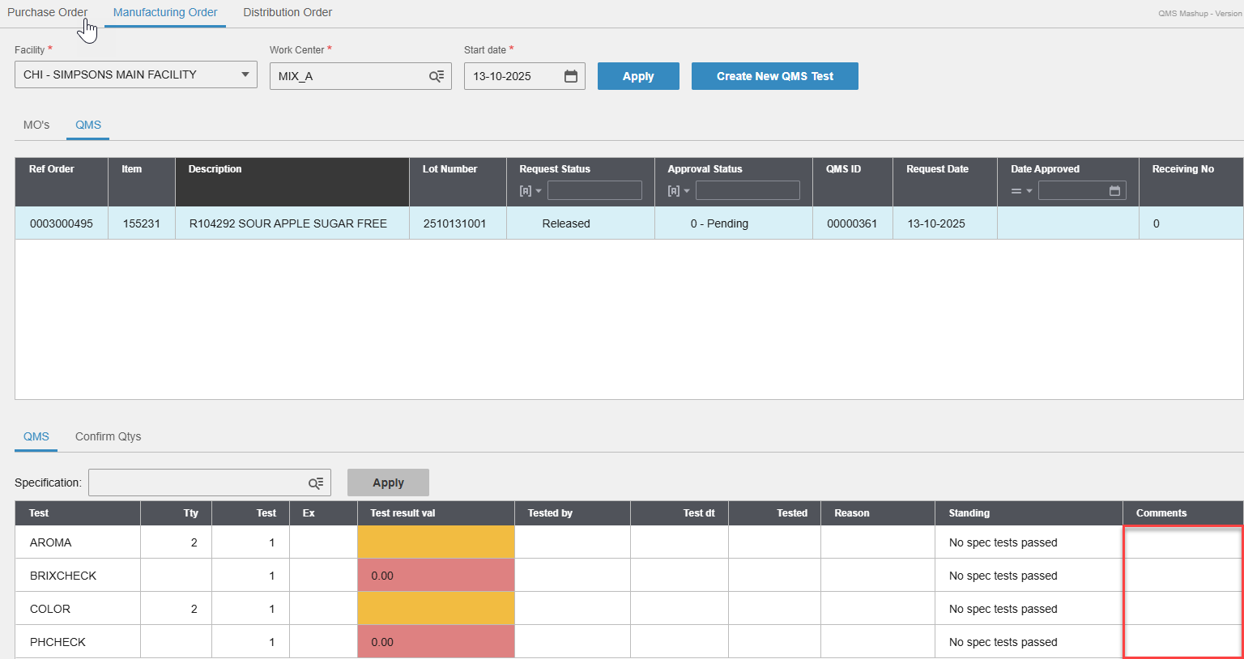
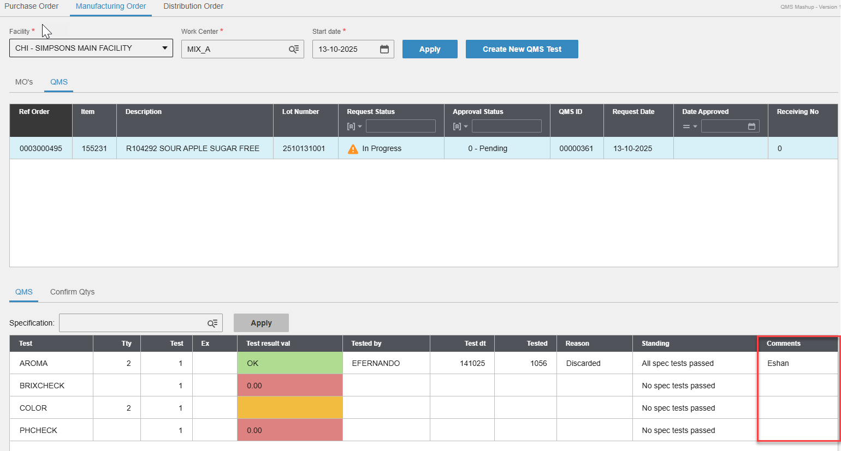
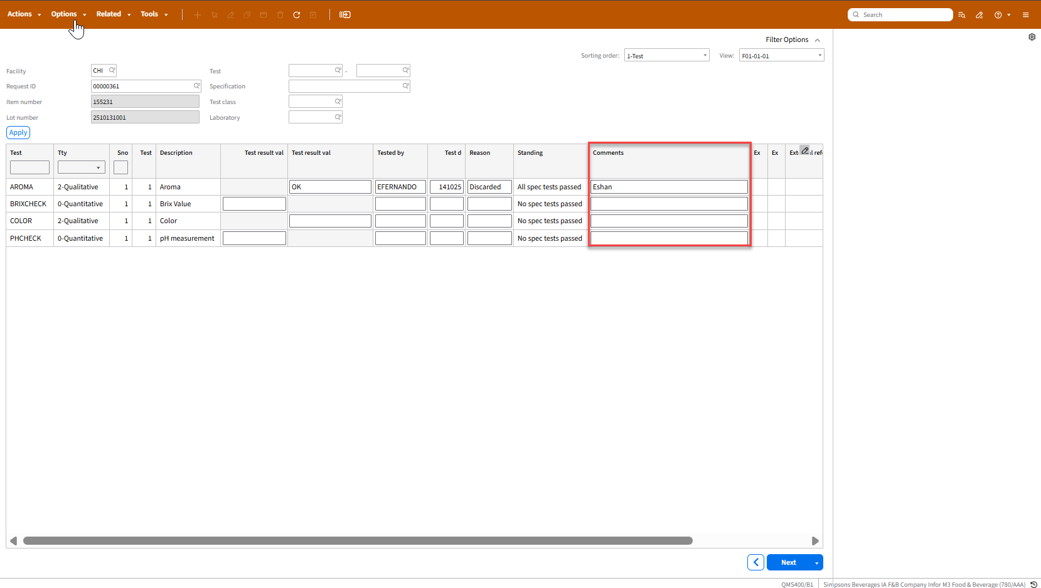
- Target value, expected minimum, expected maximum values on QMS201 record (Item, specification record) to be displayed on ‘Ex’ column on the Mashup
